Introduction to Cardiovascular Fitness
Total lesson time: 00:47:30

Lesson Breakdown
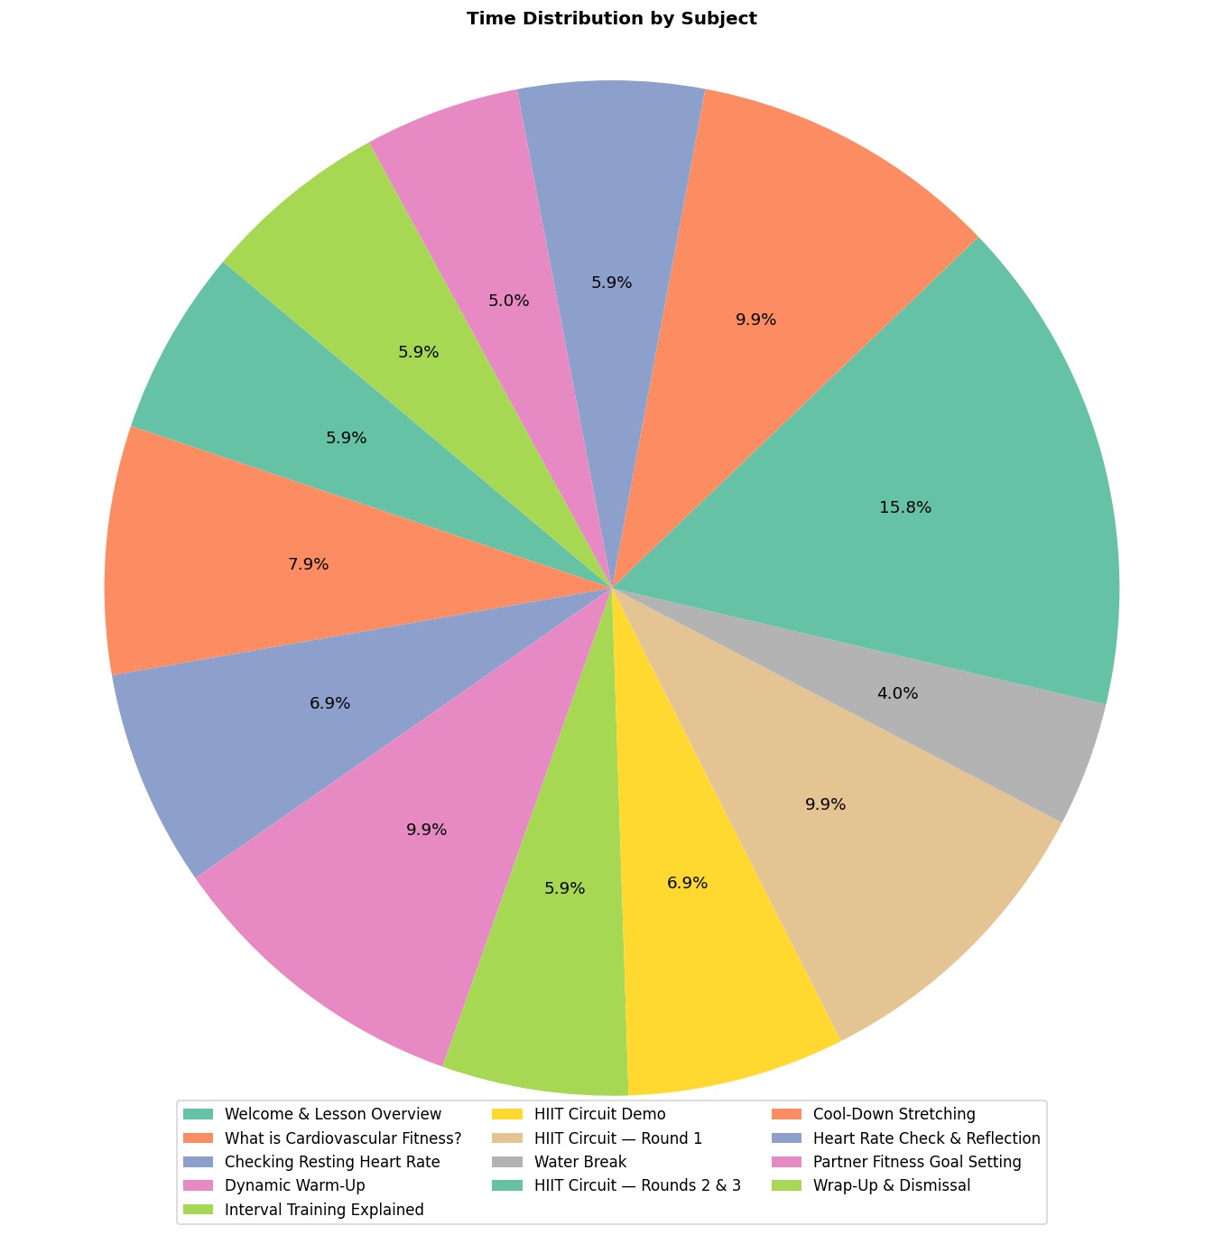
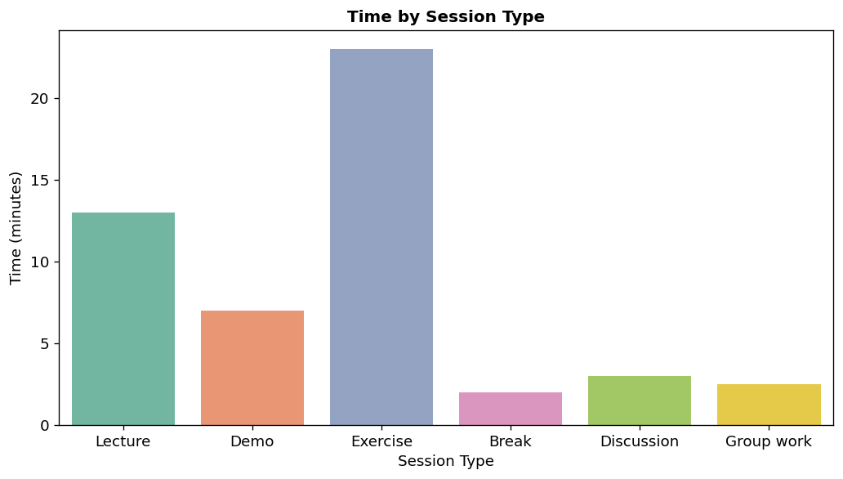

Welcome & Lesson Overview
Lecture | Time: 00:03:00

Welcome to PE!
Today we'll be focusing on cardiovascular fitness — what it is, why it matters, and how to improve it.
#### Today's Goals:
- Understand what cardiovascular fitness means
- Complete a warm-up routine
- Learn and practice interval training
- Cool down safely
- Reflect on the session as a group
> Make sure you have water and appropriate footwear before we begin!

What is Cardiovascular Fitness?
Lecture | Time: 00:04:00

Cardiovascular Fitness
Cardiovascular fitness refers to the ability of the heart, lungs, and blood vessels to deliver oxygen to working muscles during sustained physical activity.
#### Key Terms:
- Heart Rate — beats per minute (BPM)
- Aerobic Exercise — activity that raises your heart rate for an extended period
- VO2 Max — the maximum rate of oxygen your body can use
#### Why does it matter?
- Reduces risk of heart disease
- Improves energy levels
- Supports mental health
- Increases endurance

Checking Resting Heart Rate
Demo | Time: 00:03:30

Demo: Finding Your Pulse
Before we get moving, let's establish your resting heart rate (RHR).
#### How to find your pulse:
- Place two fingers on the inside of your wrist (radial pulse) or the side of your neck (carotid pulse)
- Count the beats for 30 seconds
- Multiply by 2 to get your BPM
#### Average Resting Heart Rates:
| Age Group | Average RHR |
|-----------|-------------|
| Children (6–15) | 70–100 BPM |
| Adults (18+) | 60–100 BPM |
| Athletes | 40–60 BPM |
> Write down your RHR — we'll compare it after the workout!

Dynamic Warm-Up
Exercise | Time: 00:05:00

Dynamic Warm-Up (5 Minutes)
Let's get the body ready! Follow along with each exercise:
#### Circuit (45 sec each):
- Jogging on the spot
- Arm circles — forward then backward
- High knees
- Leg swings — front/back and side-to-side
- Butt kicks
- Hip rotations
> Focus on controlled movements — this is a warm-up, not a race!

Interval Training Explained
Lecture | Time: 00:03:00

What is Interval Training?
Interval training alternates between periods of high-intensity effort and lower-intensity recovery.
#### Today's Format — HIIT (High-Intensity Interval Training):
- Work period: 40 seconds
- Rest period: 20 seconds
- Rounds: 3 sets of the full circuit
#### Benefits:
- Burns more calories in less time
- Improves aerobic and anaerobic fitness
- Keeps things interesting!
> Aim to work at 70–85% of your maximum effort during work periods.

HIIT Circuit Demo
Demo | Time: 00:03:30

Demo: Full Circuit Walkthrough
Before we go full speed, I'll demonstrate each exercise so everyone knows the correct form.
#### The 5 Exercises:
- Jumping Jacks — arms and legs together
- Squat Jumps — land softly, knees tracking over toes
- Mountain Climbers — keep hips level
- Push-Ups — modify on knees if needed
- Burpees — step version available as a modification
> Modifications are always available — listen to your body!

HIIT Circuit — Round 1
Exercise | Time: 00:05:00

Round 1 — Let's Go! 🔥
Complete each exercise for 40 seconds, then rest for 20 seconds before moving on.
- Jumping Jacks
- Squat Jumps
- Mountain Climbers
- Push-Ups
- Burpees
> Push yourself — but stay in control of your movements!

Water Break
Break | Time: 00:02:00

Water Break — 2 Minutes
Take this time to:
- Hydrate — take a good drink of water
- Catch your breath
- Walk around slowly to keep blood circulating
> We'll start Round 2 in 2 minutes!

HIIT Circuit — Rounds 2 & 3
Exercise | Time: 00:08:00

Rounds 2 & 3 — Keep It Up!
Same format as Round 1. 40 sec on / 20 sec rest.
#### Round 2:
- Jumping Jacks → Squat Jumps → Mountain Climbers → Push-Ups → Burpees
#### Short Rest (60 sec)
#### Round 3:
- Jumping Jacks → Squat Jumps → Mountain Climbers → Push-Ups → Burpees
> Final round — give it everything you've got!

Cool-Down Stretching
Exercise | Time: 00:05:00

Cool-Down — Static Stretching (5 Minutes)
Slowly bring your heart rate down with these held stretches (30 sec each):
- Standing quad stretch — hold ankle, balance on one foot
- Hamstring stretch — seated or standing toe touch
- Hip flexor lunge stretch — deep lunge, back knee down
- Chest opener — clasp hands behind back, open chest
- Shoulder cross-body stretch
- Child's pose — hold for 60 seconds to finish
> Breathe deeply through each stretch. Never bounce — hold steady.

Heart Rate Check & Reflection
Discussion | Time: 00:03:00

Post-Workout Check-In
Let's take our pulse again and compare to our resting heart rate from earlier.
#### Discussion Questions:
- How does your heart rate now compare to your resting rate?
- Which exercise did you find most challenging? Why?
- How does your body feel after the session?
- What would you do differently next time?
> Share with a partner first, then we'll open it up to the group.

Partner Fitness Goal Setting
Group work | Time: 00:02:30

Setting a Fitness Goal
With a partner, use the SMART goal framework to set one fitness goal for the next 2 weeks.
#### SMART Goals:
| Letter | Meaning | Example |
|--------|---------|----------|
| S | Specific | "I will run 3x per week" |
| M | Measurable | "For 20 minutes each time" |
| A | Achievable | "Starting with a walk/run mix" |
| R | Relevant | "To improve my 1-mile time" |
| T | Time-bound | "Over the next 2 weeks" |
> Write your goal down — you'll review it at our next session!

Wrap-Up & Dismissal
Lecture | Time: 00:03:00

Great Work Today!
#### What We Covered:
- [X] Cardiovascular fitness fundamentals
- [X] Resting heart rate measurement
- [X] Dynamic warm-up techniques
- [X] HIIT interval training (3 rounds!)
- [X] Safe cool-down and stretching
- [X] SMART goal setting
#### For Next Class:
- Bring your written SMART goal
- Try to do one active activity before we meet again
- Optional: track your steps or active minutes
> See you next time — keep moving!

